HW2

URL for Website: <https://theo-dayton.github.io/bwebsite/index.html>

Design Document:

* Name of business: Big Chungus Games
* What the business does: It is a Video Game publisher
* Target demographic: Teenagers and young adults
* How will the website help the business: The website will help both showcase its range of products as well as reach more people that may be interested in buying their product.
* Home page design sketch:

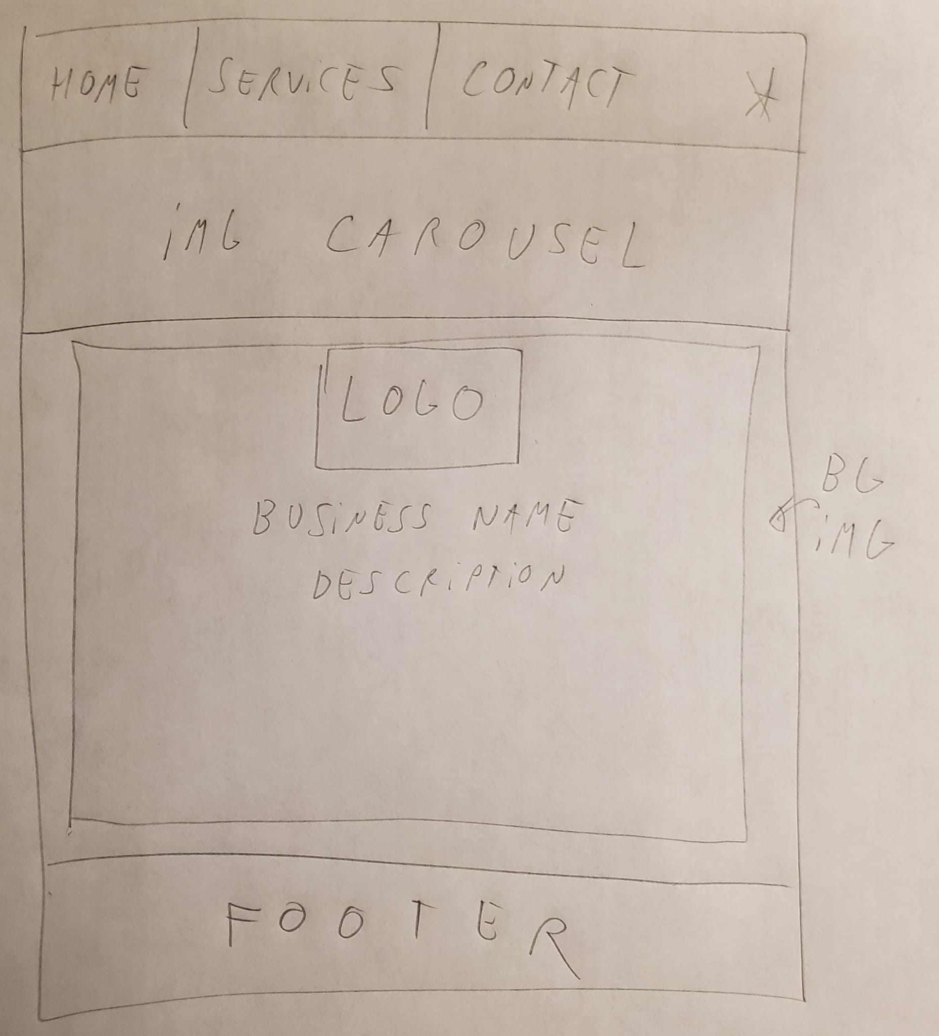

Questions:

**What was the easiest part of this assignment?**

The easiest part of this assignment was thinking about the design of the webpage and how it should look in the end

**What was the most challenging part of this assignment?**

The most challenging part was getting the various elements of the webpage to fit together nicely, as well as making the page responsive with the changing screen size.